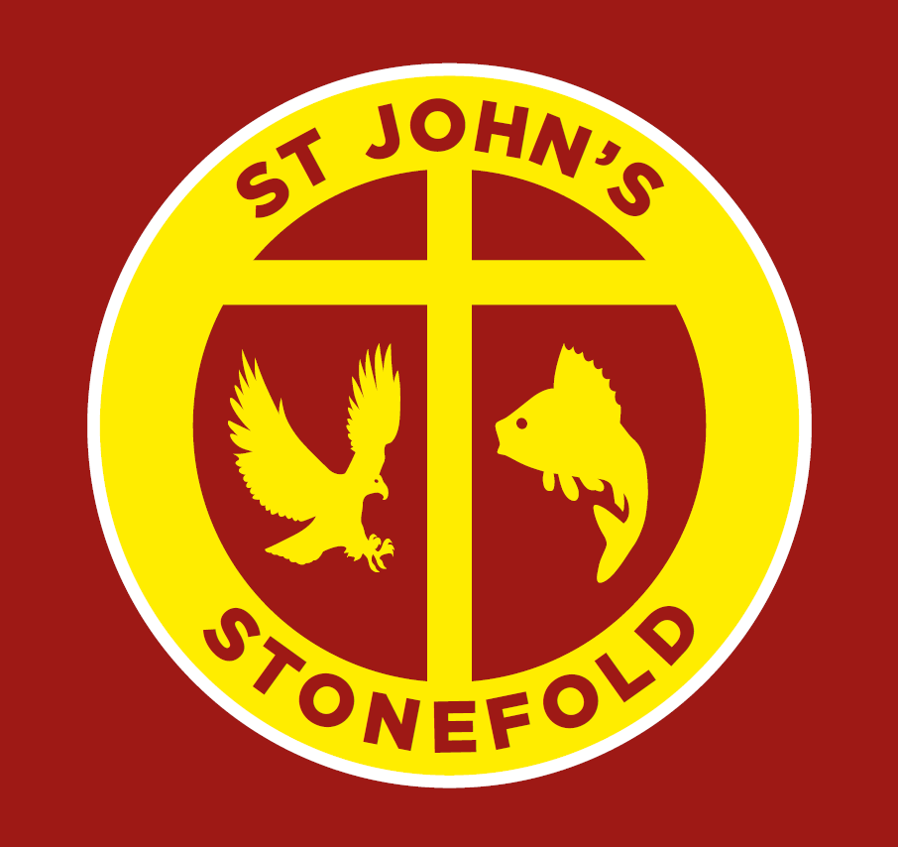

St John’s Stonefold CE Primary School, Rising Bridge

Whole School Policy for English
Written By | K. Isherwood
Date | June 2022
Approved by FGB
Date of Review

Values:
Empathy Aspiration Generosity Love Endurance
Mission:
Rooted and Established in God’s Love: Nurture, Grow, Fly (Ephesians 3:17)
Vision:
Our vision is to live and grow together as a loving church school family, who celebrate one another’s individuality. Built upon our shared Christian values, St John’s provides our children with excellent teaching of a bespoke and innovative curriculum, empowering them to flourish with the knowledge and skills for life.
From our vision, we inspire our children to have uncompromising aspirations and to thrive and succeed.

English Policy

INTENT

At St John’s we aim to inspire our pupils to acquire the necessary knowledge, skills and understanding to become lifelong learners and linguists. Our vision is for all pupils to be fluent, confident readers who have a firm grasp of an extensive vocabulary which is used in all lessons across the curriculum. We strive to ensure that all our pupils receive a well-rounded learning experience when reading, writing, speaking and listening which will equip them with the fundamental tools to achieve. It is our intention to immerse pupils in the wonders of quality texts to instil a love for reading, a passion for discovery and a confidence to explore their imagination through our curriculum. We want all pupils to develop a love of reading and explore a variety of texts and authors in lessons and independently.
Through our English curriculum, we strive to teach the children how important their reading, writing, speaking and listening skills will be in the real world. By giving this context to their learning, the children understand the value of English to them now, and in their futures.

By the age of 11 we aim for a child to be able to:

- speak, read and write with confidence, fluency and understanding, orchestrating a range of independent strategies to self-monitor and correct.
- be competent in the arts of speaking and listening, making formal presentations, demonstrating to others and participating in debate.
- use discussion in order to learn; they should be able to elaborate and explain clearly their understanding and ideas;
- develop the habit of reading widely and often, for both pleasure and information;
- have an interest in words, their meanings; developing a growing vocabulary in spoken and written forms.
- acquire a wide vocabulary, an understanding of grammar and knowledge of linguistic conventions for reading, writing and spoken language;
- develop an appreciation of our rich and varied literary heritage;
- articulate and communicate ideas, write clearly, accurately and coherently, adapting their language and style in and for a range of contexts, purposes and audiences;
- be developing the powers of imagination, inventiveness and critical awareness.
- spell quickly and accurately through knowing the relationship between sounds and letters (phonics) and understanding the morphology (word structure) and orthography (spelling structure) of words.
- be skilled at word reading quickly working out of the pronunciation of unfamiliar printed words (decoding) and the speedy recognition of familiar printed words
- have good comprehension of what they read, drawn from linguistic knowledge (in particular of vocabulary and grammar) and on knowledge of the world.

Implementation

St John’s English curriculum is planned from the National Curriculum (2014). English units, planned around the NC programmes of study have been developed to support cross-curricular themes. St John’s has a long-term plan of themes and key learning for each class to ensure there is a clear sequence of progression from EYFS through to the NC.

English is taught in ‘phases’ in English lessons in KS1 and KS2.

Phase 1 – this is the reading phase. The teacher studies a book or novel with the children and learning is based around this reading. Vocabulary, fluency and understanding all focus within the sessions.

Phase 2 – this is the gathering content phase. Here information (such as vocabulary and sentence structure) is gathered during learning which will aid and support the writing which will follow.

Phase 3 – this is the writing phase. In this phase, the teacher scaffolds the writing which supports the children in their progress and development of writing.

In order to develop independent writing alongside the phases, each teacher implements outcome 1, 2 and 3 into their teaching.

Outcome 1 – The teacher scaffolds the writing for the children during English lessons.

Outcome 2 – The children are given an opportunity sometime later (perhaps a week) to write in the same genre but without scaffolding. This is classed as independent writing.

Outcome 3 – The children are given an opportunity to use their learning across the curriculum.

Children in EYFS, Year 1 (and if needed, Year 2) learn to read through Read, Write Inc. phonics scheme. Please see the RWI policy.

Children in Years 2-6 take part in daily guided reading lessons.

In Key Stage One and Key Stage Two classes, grammar is taught discretely through phases one and two and its application is taught during phase 3. Spelling is taught discretely and application is encouraged throughout.

Across the school handwriting is taught in a pre-cursive and then continuous cursive script discretely using some resources from letter-join scheme of work. In Foundation Stage, handwriting is linked to phonics and planned for during continuous provision. This includes both child initiated and adult directed activities. In Key Stage One and Key Stage Two, handwriting is taught discretely and applied across the curriculum.

IMPACT

The phases approach to English have been introduced and we expect to see progress throughout the next academic year.

RWI phonics will be introduced in September and data will be quickly gathered. It is expected that children in EYFS, Year 1 and some Year 2 will make rapid progress in their reading, writing, fluency and comprehension.

Children have attained well in reading and writing at the end of KS2. Further progress is expected throughout the next academic year.

STATUTORY REQUIREMENTS

Statutory requirements for the teaching and learning of English are laid out in the National Curriculum English Document (2014) and in the Statutory Framework for the Early Years Foundation Stage (2021)

The Early Years Foundation Stage (Reception) will lay strong foundations to help children achieve the intentions described above and should be given opportunities to:
- Have frequent and quality conversations with adults and other pupils who will provide commentary on what children are interested in or doing, and echo back what they say with new vocabulary added, practitioners will then build children's language effectively.
- Hear, share and discuss and engage in stories, non-fiction, rhymes and poems.
- speak and listen and represent ideas in their activities;
- use communication, questioning, language and literacy in every part of the curriculum;
- become immersed in an environment rich in print.
- Follow the RWI scheme for phonics, reading and writing.

At Key Stage One (Years 1 and 2), children should learn to speak confidently and listen to what others have to say. They should begin to read and write, fiction, non-fiction and poetry independently and with enthusiasm. They should use language to explore their own experiences and imaginary worlds.
Children in Year 1, and some in Year 2, will follow the RWI scheme for phonics, reading and writing.

At Key Stage Two (Years 3-6), children should learn to change the way they speak and write to suit different situations, purposes and audiences. They should read a range of texts and genres (fiction, non-fiction and poetry) and respond to different layers of meaning in them. They should explore the use of language in literary and non-literary texts and learn how the structure of language works.

THE GOVERNORING BODY

Termly reports are made to the governors in the Head teacher’s report on standards of attainment and progress in English. More detailed reports are made by the subject leaders to Governors at least once per year. There is a named governor with responsibility for English (see school website) who makes regular visits to school to monitor this policy and standards in this subject.

SUBJECT ORGANISATION

The skills which are taught to each year group are clearly outlined for teachers in the learning and progression steps (LAPS) documents in phonics, reading and writing and guidance to judge performance in English is provided in the Key learning indicators of performance (KLIPS) for reading and writing for Year 1 to 6.

English is taught daily in every class and additional tailored intervention is provided for children with gaps in learning. Focussed additional tuition is provided using TA’s and planned by teachers for Year 6 and Year 2 pupils in the Spring if gaps in learning are identified.

The learning in English supported and enhanced by:
- using working walls within classrooms
- celebrating world book day
- visitors to and visits outside of school by authors and poets

Opportunities to revisit previous learning is provided in grammar warm-ups and editing lessons

APPROACHES TO SPOKEN LANGUAGE

In order to meet the requirements of the national curriculum programmes of study, activities such as speaking, listening, group discussion and drama are planned for at an age appropriate level. Interactive teaching strategies (see Teaching and Learning Policy 2021) are used to engage all pupils in order to raise reading and writing standards. Children are encouraged to develop effective communication skills in readiness for later life.
Children are encouraged from the Reception class onwards to talk about experiences both in and out of school. Opportunities for imaginative play take place daily in foundation stage and can continue during Key Stage One where appropriate. Older children are also given the opportunity to discuss and debate more complex issues e.g. the environment or topical items of news. Some opportunity will be given for all children to learn poetry by heart and perform for a range of audiences.

Whole school worship led by a class enable every child in school to stand and talk to a large audience of adult visitors. Participating in school plays and school services in school and Church provide more opportunities of a similar nature.

Children are given opportunities to listen to various adult speakers who come into school to share their expertise and knowledge. Learning to ask thoughtful, pertinent questions during and after such visits is encouraged.

Children can develop their speaking and listening skills through the use of ICT. They have the opportunities to record and listen back to recordings of themselves and others and can evaluate their speaking performances.

APPROACHES TO READING

We aim to develop a positive reading culture throughout school. Each class has a designated reading area, which children have access to within guided reading sessions and also at other times of the day. There is a central school library in the main corridor and in the Perch room, which pupils can select books from and take to class.
EYFS and KS1 children will be sent home with copies of the RWI book they are currently reading in school. This will be supplemented by RWI Book Bag Books. Each book will be read three times in school before the next text is started.
KS2 children also have access to an online library of books with a login to ‘Bug Club’, where teachers can allocate books at an appropriate level for each pupil. Teachers share a book with each class at the end of the day to provide children with an enjoyment of books and to enrich their cultural experiences and to encounter and discuss unfamiliar vocabulary.
We believe that good reading teaching is achieved through teaching a combination of word reading and comprehension skills.

SHARED READING

English lessons in Phase One and Two often feature the use of an age appropriate shared text which is clearly visible for all children. During lessons, teachers model reading using punctuation and of appropriate expression which can then be mirrored by the children. Together they re-read a section of the text before discussing. Each shared reading session is based around an age appropriate objective and is used to develop children’s comprehension, vocabulary knowledge, and their ability to analyse the author’s use of language and structure. In the first reading phase of an English unit of work, key reading comprehension and decoding skills are taught and linked to responses in writing e.g. ‘to infer character thoughts’ may be included when writing a diary in role. In addition, this phase allows teachers to focus on teaching vocabulary and key words are identified for pre-teaching or exploring during reading sessions. These are displayed on English working walls and are referred to and revisited throughout the teaching of the English unit.

GROUP GUIDED READING

At St John’s the differentiated teaching of reading is delivered through daily group guided reading sessions in Y2-Y6.
In EYFS and KS1, all reading is learnt through RWI.

The objective of the guided reading session is based upon pupil needs and next steps.

During guided reading, each pupil has access to a copy of the novel/text (A mix of Fiction, Non-Fiction and Poetry) so that they can be fully engaged in their learning. The teachr’s questioning and the pupils’ learning is based around six key dimensions: Word reading, Pleasure, Understanding, Information retrieval, Discussion (personal response) which link directly to the reading domains and assessment (LAPS) focus areas.

HOME READING

Once children have settled in to school, after approximately 4 weeks, Reception parents are invited to a RWI phonics meeting to outline the development of reading within school. This also explains the importance of reading at home with their child.

In EYFS, Year 1 and some Year 2, will take home a RWI book which they have been reading that week in their phonics lessons. They will also take home an additional RWI Book Bag book. Parents are expected to read with their child a minimum of 3x a week.

From grey level books onwards, all children are allocated a reading book to take home. This is from a colour coded Book Banding scheme in order that the child’s book will be appropriate for their reading age.

In addition to this, all children have the opportunity to select a library book from their reading area and read independently in school each week.

PHONICS

In EYFS, Year 1 and some Year 2, phonics is taught daily using Read Write, Inc.
Children who fail to reach the expected standard as measured by the year one phonic check, take part in additional sessions using the RWI intervention scheme. Children who have not acquired the age appropriate decoding skills by the end of Key Stage One, take part in tailored intervention sessions in KS2.
See the phonics policy for more detailed information.

APPROACHES TO WRITING

At St John’s the reading to writing teaching sequence ensures that written outcomes reflect a breadth of relevant reading experience and opportunities to write for a range of audiences and purpose.
We believe that good writing teaching is achieved through teaching a combination of transcription skills (spelling and handwriting) and composition (articulating ideas and structuring them in speech and writing).

In EYFS, children will use emergent writing strategies to begin their writing process beginning to apply phonic knowledge in line with their development. Children will complete their writing using the RWI phonics scheme.

During the English lesson teachers will demonstrate writing skills through shared and modelled writing. This allows the children to see the processes involved in writing including planning, composition, editing and improving. The application of the focused grammar skill is modelled by the teacher and included in success criteria for the children. In KS1 spelling and handwriting is taught within phonics lessons and further opportunities for additional practise is planned into the week’s learning activities. In KS2 Spelling and handwriting is taught in discrete lessons for 15 minutes every day.

At St John’s differentiated teaching of writing takes place in class with groups of children being led by the teacher or teaching assistant. This guided session allows teachers and pupils to focus on a specific writing target.

Each English unit will result in a final independent writing task. There are also other incidental short writing opportunities planned within each unit. These will include a short write linked to the reading element of planning, then a scaffolded piece whereby the teacher models writing skills (including grammar focus) in context and the children then produce their own similar piece. This is usually completed over several days with the teacher modelling daily. These pieces of writing are subject to feedback individually given (verbal and/or written) and will include improvement points. The final outcome is an independent piece whereby the children produce an extended piece of writing. The children are given greater opportunity to plan and write this piece more independently i.e. there is no shared writing. This may be used as an assessment of the children’s progress across the unit and is marked in a summative fashion.

CROSS-CURRICULAR LITERACY OPPORTUNITIES

As well as the planned writing outcomes taught in the English units, additional opportunities will be provided for the children to write across the curriculum. Children also have a weekly planned Big Write lesson where children are provided with a stimulus for writing, allowed to discuss and share ideas for a genre they have previously been taught and could be a cross-curricular context linked to another subject.

THE USE OF TECHNOLOGY

Opportunities to use laptops and i-pads to support teaching and learning in English will be planned for and used as appropriate.

ASSESSMENT AND TARGET SETTING

EYFS assessment and data will be gathered as per the RWI policy. Each child will be initially assessed after 4 weeks of receiving daily phonics, and then once a half term. Groups will be fluid and match the most recent RWI data.

Work will be assessed in line with the Assessment Policy. Formative assessment (observations and questioning and marking) throughout a unit is used to inform teachers of children’s immediate next steps and future learning and then incorporated into planning of the next unit. Teachers use KLIPS and LAPS to support their summative and formative assessments throughout the year and set appropriate targets for pupils. Independent writing tasks should have the success criteria stuck in next to the work and marking should be geared towards this. Regular summative review of writing progress allows teachers to target different aspects for groups or individuals within their daily teaching and with the support of their TAs.

INCLUSION & CHALLENGE

We ensure consistently good teaching so that all children can reach their maximum potential in English. More able children will be identified and suitable learning challenges provided. We will ensure that texts provide challenge in terms of vocabulary and content.
Learners who are struggling to achieve year group expectations are identified by teachers and are then supported to develop phonics, spelling, reading, grammar or writing skills through the use of timely intervention enabling them to keep up or catch up with their peers.
Some children may need more targeted interventions and smaller steps towards progress planned in their learning support plans (refer to SEN policy).

EQUAL OPPORTUNITIES

All children are provided with equal access to the English curriculum. We aim to provide suitable learning opportunities regardless of gender, ethnicity or home background. Please see equalities policy.

ROLE OF SUBJECT LEADER:

The subject leader is responsible for improving the standards of teaching and learning in English through:
Monitoring and evaluating the IMPACT of English teaching by reviewing:
- pupil progress
- provision of English (including Intervention and Support programmes)
- the quality of the Learning Environment;
- the deployment and provision of support staff
- the effectiveness of this policy (during meetings with nominated governors)
AND
- Taking the lead in policy development
- Auditing and supporting colleagues in their CPD
- Purchasing and organising resources
- Keeping up to date with recent Literacy developments
- Developing action plans to improve progress and outcomes for children in English.

PARENTAL INVOLVEMENT

At St John’s CE Primary School, we believe that parents play a vital part in their child’s education and as such, we attempt to involve them at every level of their child’s learning in English, especially with the development of reading skills. Parent workshops for phonics, reading and writing will be held throughout the year. There is an open door policy at St John’s and parents are encouraged to contact staff with questions and queries.

CONCLUSION:

This policy also needs to be in line with other school polices and therefore should be read in conjunction with the following school policies:

Teaching and Learning Policy
Assessment and Record Keeping
Responding to pupils’ work / Feedback / Marking policy
Special Educational Needs Policy
Computing Policy
Equal Opportunities Policy
Health and Safety Policy

